Protocol and Service Backup

Protocol and Service Backups serve the purpose of giving the Service Engineer the ability to easily and quickly re-instate the system settings. If changes are made to the system during the PM, or any other visit, having these two important backups can put the system back to its original settings, saving a lot of headache. These backups should be performed at the start of the visit, using the following procedures.

PROTOCOL BACKUP PROCEDURE

- Insert the Key Mod disc, and enter pass code. Remove Key Mod disc.
- Click the “Monitor” button on the upper right corner of the home screen. 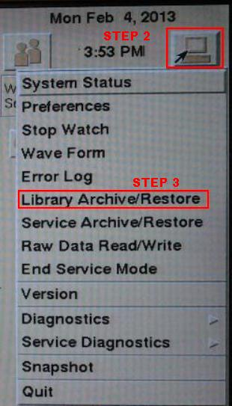
- Scroll down to “Library Archive/Restore” and click.
- Insert the Protocol Backup disc.
- Once the saved Protocols have shown up in the lower window, click “Initialize” in the lower right corner. 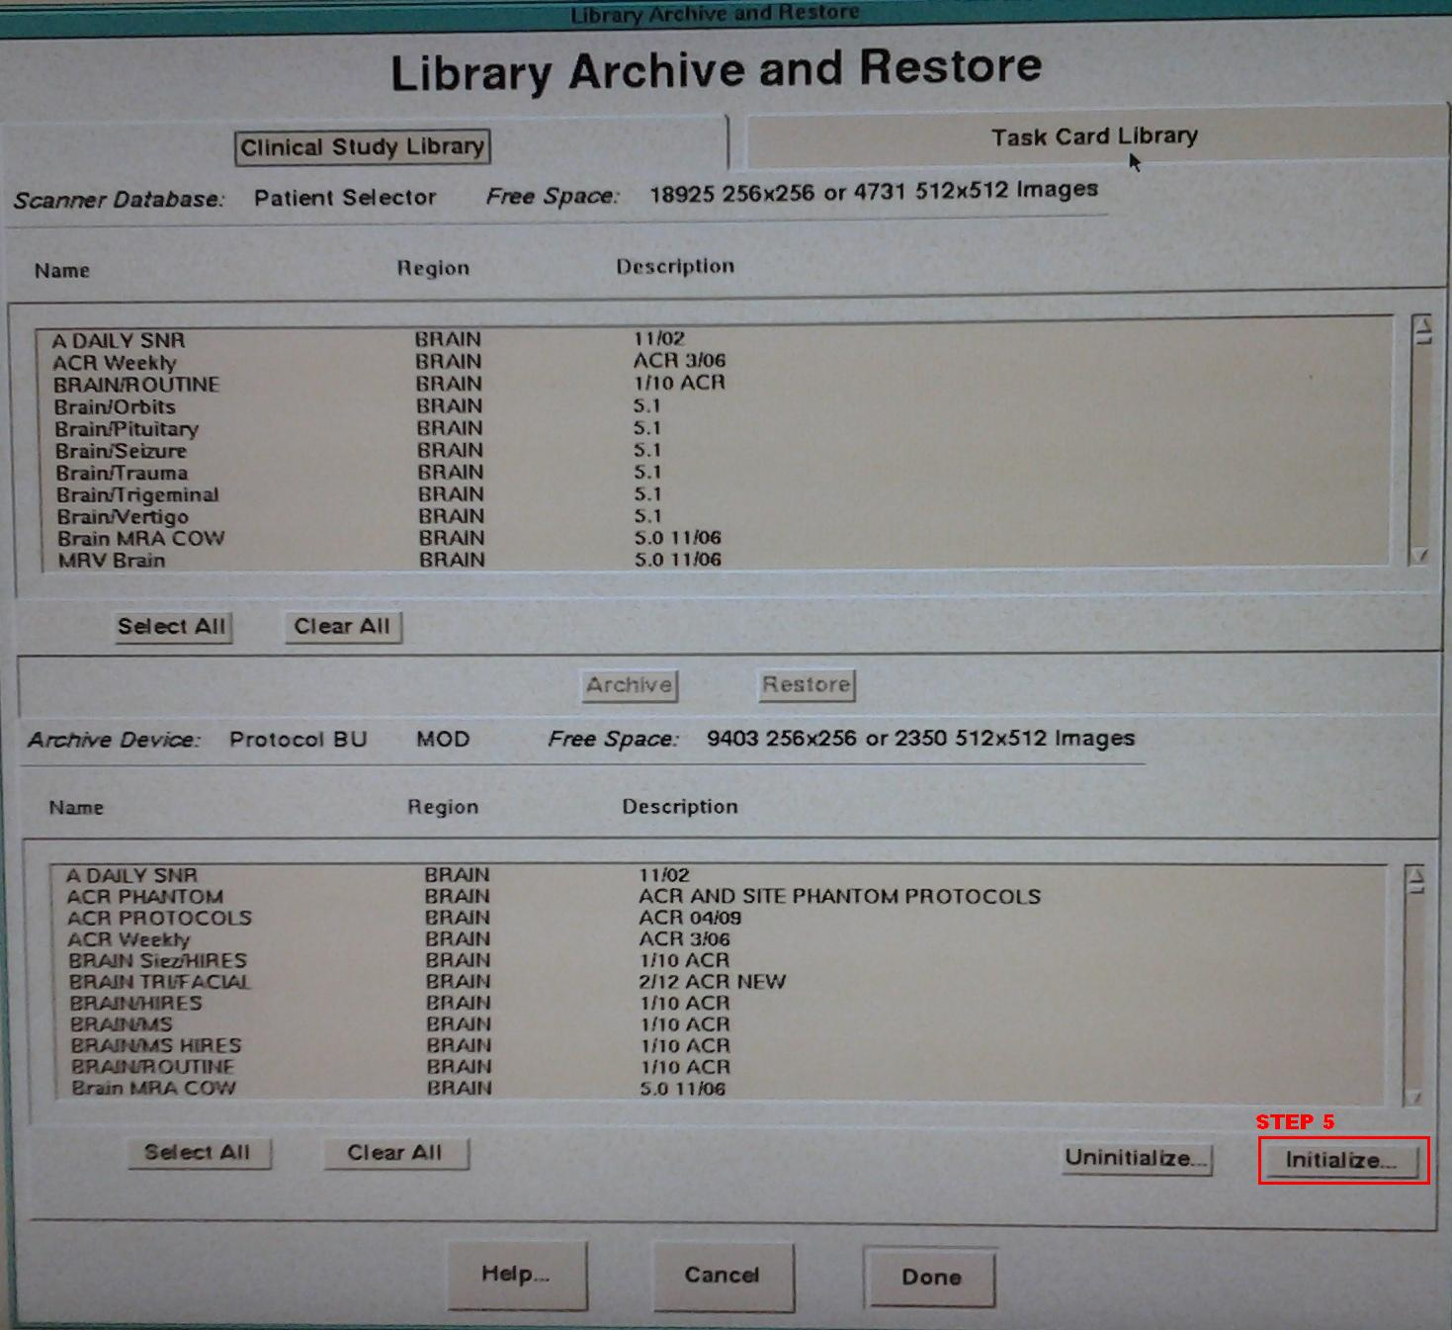
- A window warning you of the upcoming Initialize procedure will pop up: click OK to continue, CANCEL to stop the process. 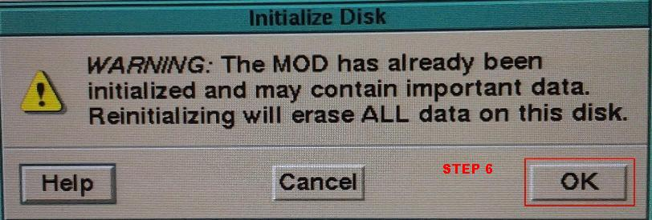
- After hitting OK to continue, a new window requesting a Volume label will appear. Enter a disc name, something like “Protocols (date)”. 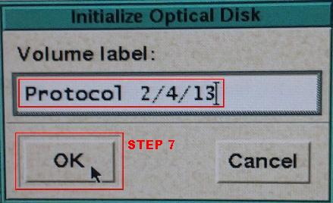
- One more window will pop up, to confirm you wish to proceed. Click “Yes”. 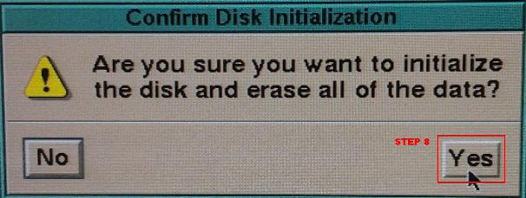
- Once the disc initializes, Click on the “Task Card Library” header at the top right of the window.
- Click “Select All” below the top list. All items in the list should now be highlighted in a darker brown color.
- Once all are highlighted, click “Archive”, located right below the highlighted files. 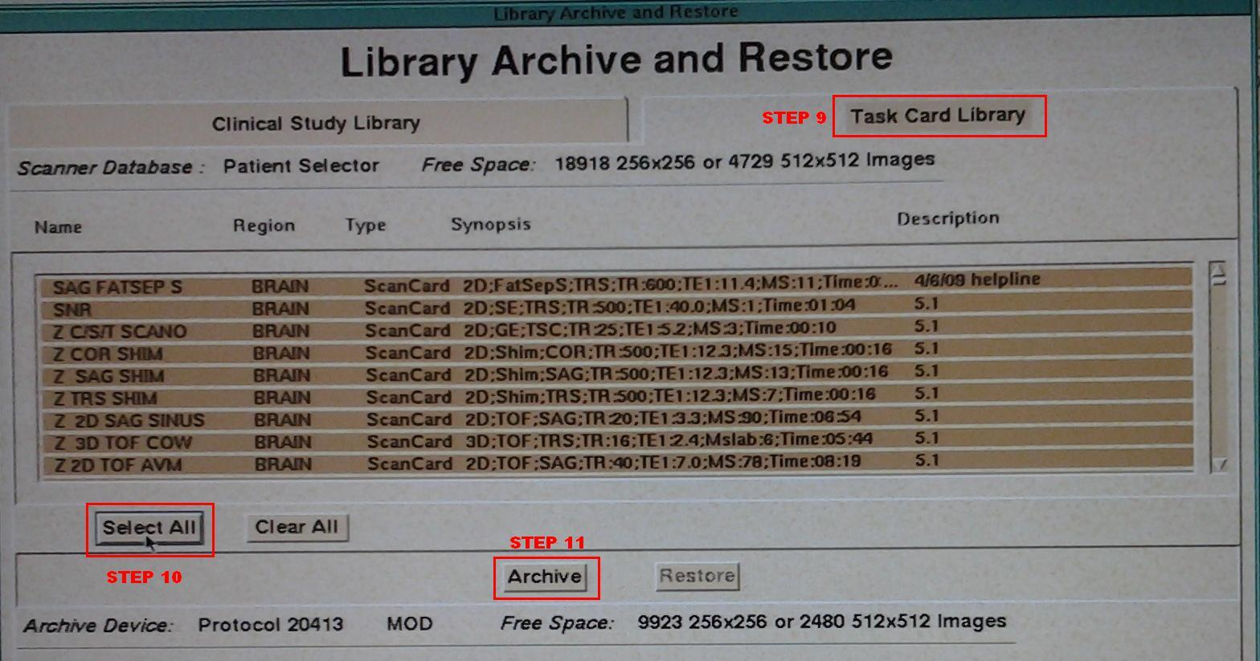
- Click on the “Clinical Study Library” header on the top left of the window.
- Again, click on “Select All” below the top list. All items in this list should also be highlighted a darker brown color now.
- Once all of these files are highlighted, click “Archive”, located right below these highlighted files. 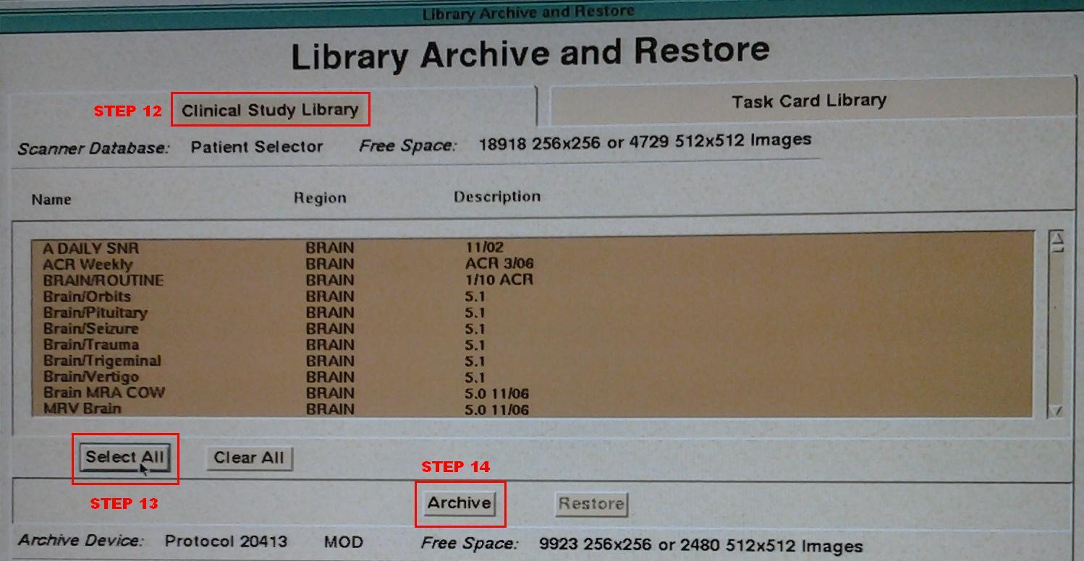
- Click on the bluish/green bar at the top of the window, and click/drag it to the left several inches, until you see the disc icon in the upper right of the home screen, now with a green dot on it. Click on that icon.
- You have now opened the “Archive Queue” and can now monitor the copying of the files you sent over for the Protocol Backup.
- You will have two groups on the bottom of the list, that are sending to the top. When both have been sent, they will reach 100%, and be removed from the lower screen. When all is done, exit this screen by hitting “Done”. 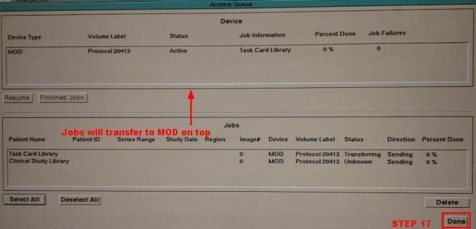
- Wait for the Protocol Backup to now load in the lower window of the “Library Archive/Restore” to verify complete, and you are done. Click “Done” to exit. Remove Protocol Backup Disc. 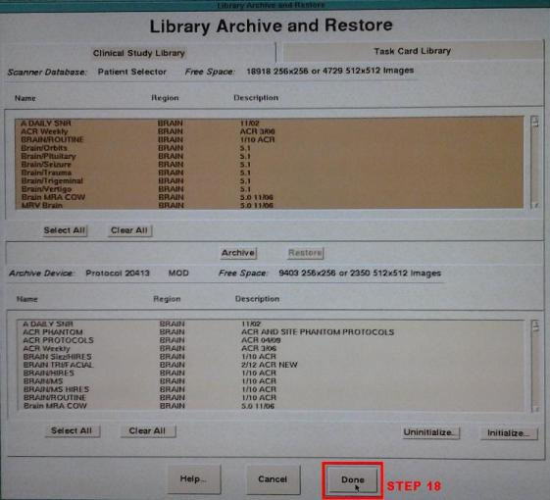
SERVICE BACKUP PROCEDURE

- Insert Key Mod disc, and enter pass code, if you haven’t already for the Protocol Backup procedure. If so, skip to step 2.
- Click on the “Monitor” button on the upper right corner of the home screen. 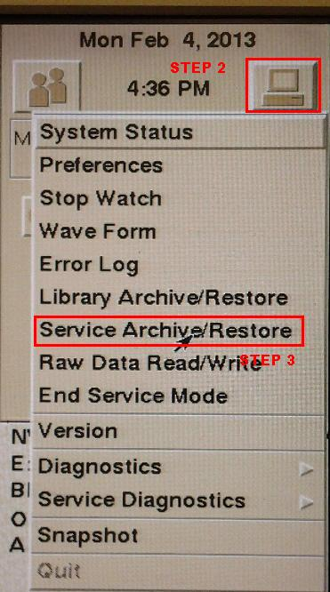
- Scroll down to “Service Archive/Restore” and click.
- Insert the Service Backup disc.
- Enter a new disc label.
- Initialize the disc by hitting the “Initialize” button. 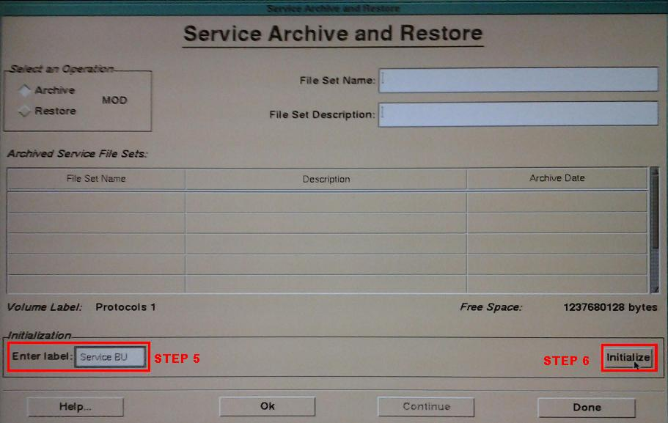
- Enter a new “File Set Name” and “File Set Description”. FSN should include the date of the visit, and FSD should show the purpose. In diagram the visit purpose was for a PM visit. 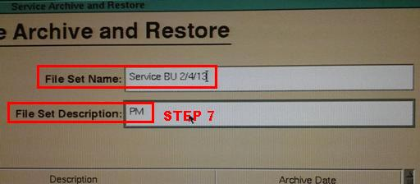
- When ready to perform the Backup, press the “OK” button at the bottom of the screen. 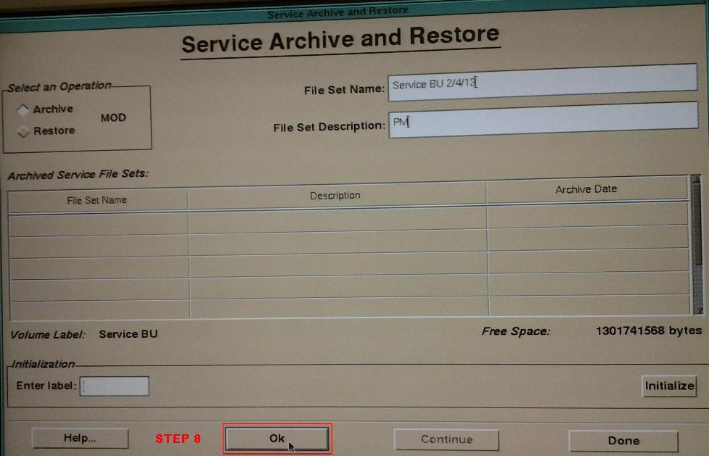
- After several moments, the Backup will complete, and the following window will appear. Click “Done”. 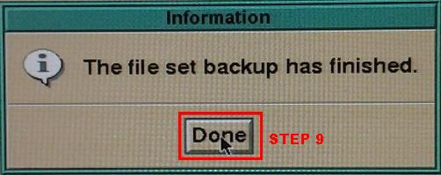
- You should now see the “File Set Name” and File Set Description” that you entered listed in the lower boxes.
- Click “Done” to complete the Service Backup and exit the screen. 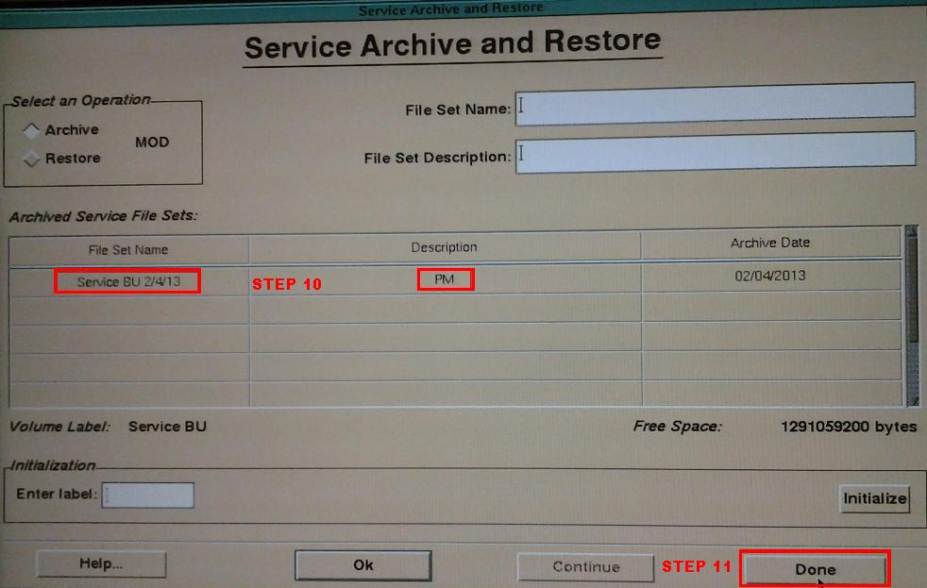

NOTES:

In both the Protocol and Service Backup procedures, it is possible to get a disc error when trying to Initialize the disc. If this occurs, the disc may very possibly be bad. Try a different disc.

